

LINGAYA’S VIDYAPEETH

2nd Year

Lab Manual

Name :- Komal Thakur

Roll No. :- 20BCA13

Course :-BCA

Branch :- Computer Science & Engineering

Subject :- Multimedia Technologies

Submit to:- Ms. Ishita Bajaj

EXP -1 ..Create Motion Tweening using Macromedia Flash(Moving Ball).

Step 1: Open macromedia flash .

Step 2: Draw a circle on the first frame from the toolbar on the left side

Step 3: Now take the mouse pointer on the first frame and right-click, a list will appear, click on Create Motion Tween

Step 4: Now the frames from 1 to 24 are being highlighted as flash is making animation on 24 frames per second and after applying motion tween it reaches to 24th frame

Step 5: Now select the box using selection tool on the keyboard and drag it to any

Step 6: It will show a motion path after placing it to any position

Step 7: Click on the play button.

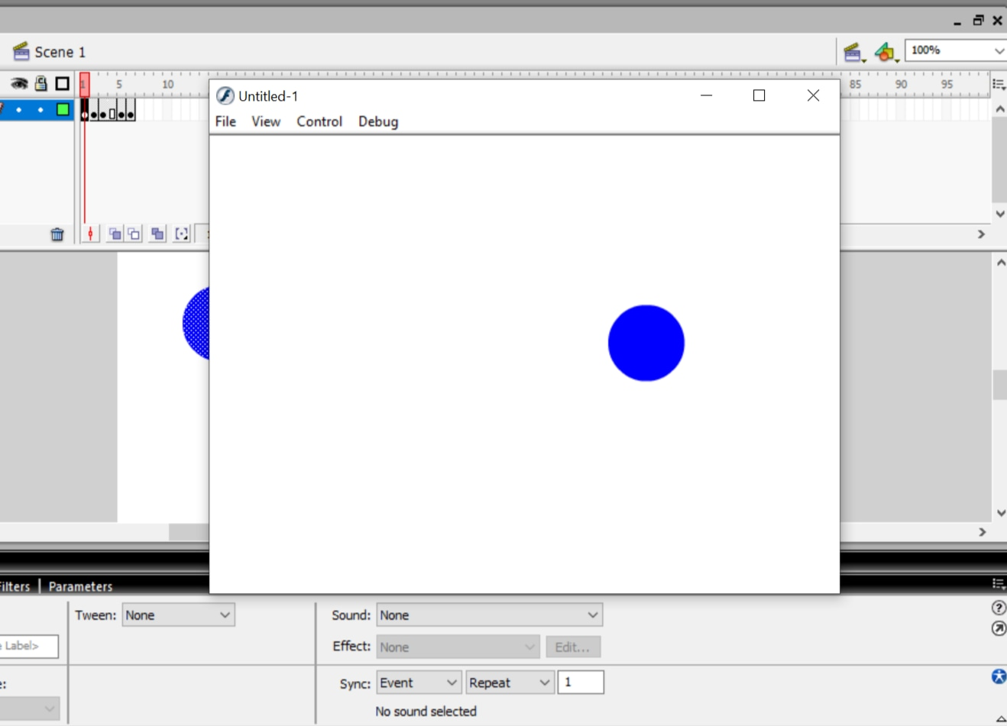

EXP -2 .. Design a moving ball in V-shape.

SOL:-

Step 1: Open macromedia flash .

Step 2: Draw a circle on the first frame from the toolbar on the left side.

Step 3: Now take the mouse pointer on the first frame and right-click, a list will appear, click on Create Motion Tween.

Step 4: Now the frames from 1 to 25 are being highlighted as flash is making animation on 25 frames per second and after applying motion tween it reaches to 25th frame.

Step 5: Now select the box using selection tool on the keyboard and drag it to in V-shape .It will show a motion path after placing it to any position.

Step 6: Click on the play button

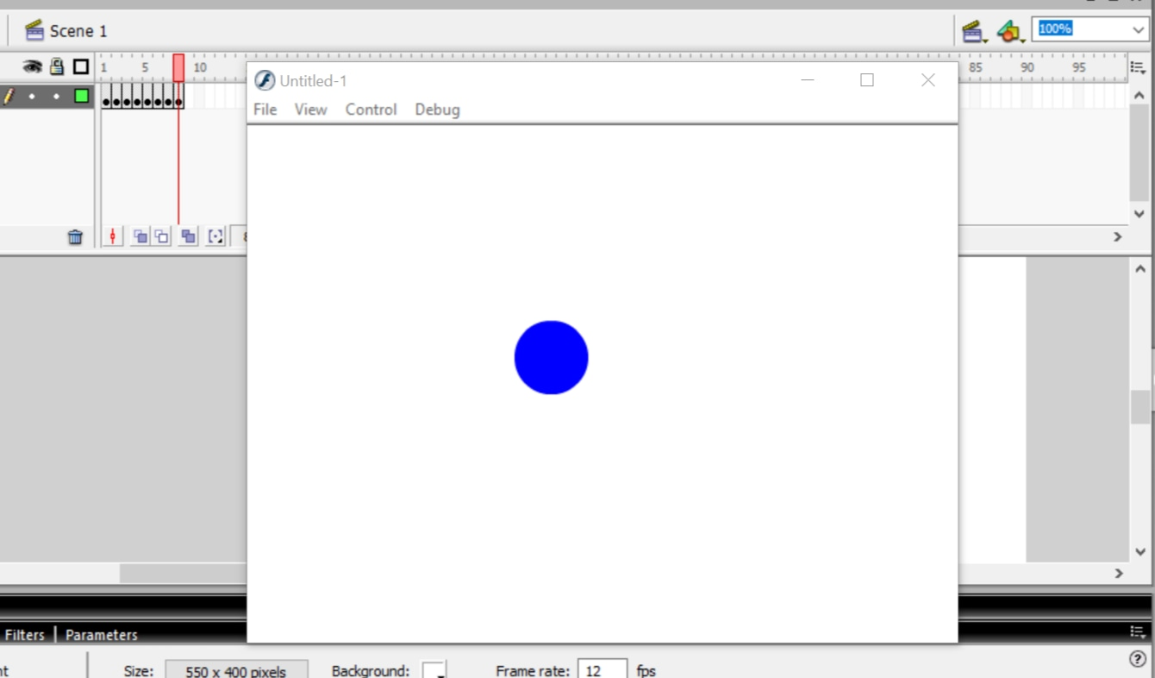

EXP 3:- .. Design a moving ball in W shape.

SOL:-

Step 1: Open macromedia flash .

Step 2: Draw a circle on the first frame from the toolbar on the left side.

Step 3: Now take the mouse pointer on the first frame and right-click, a list will appear, click on Create Motion Tween.

Step 4: Now the frames from 1 to 25 are being highlighted as flash is making animation on 25 frames per second and after applying motion tween it reaches to 25th frame.

Step 5: Now select the box using selection tool on the keyboard and drag it to in W-shape .It will show a motion path after placing it to any position.

Step 6: Click on the play button.

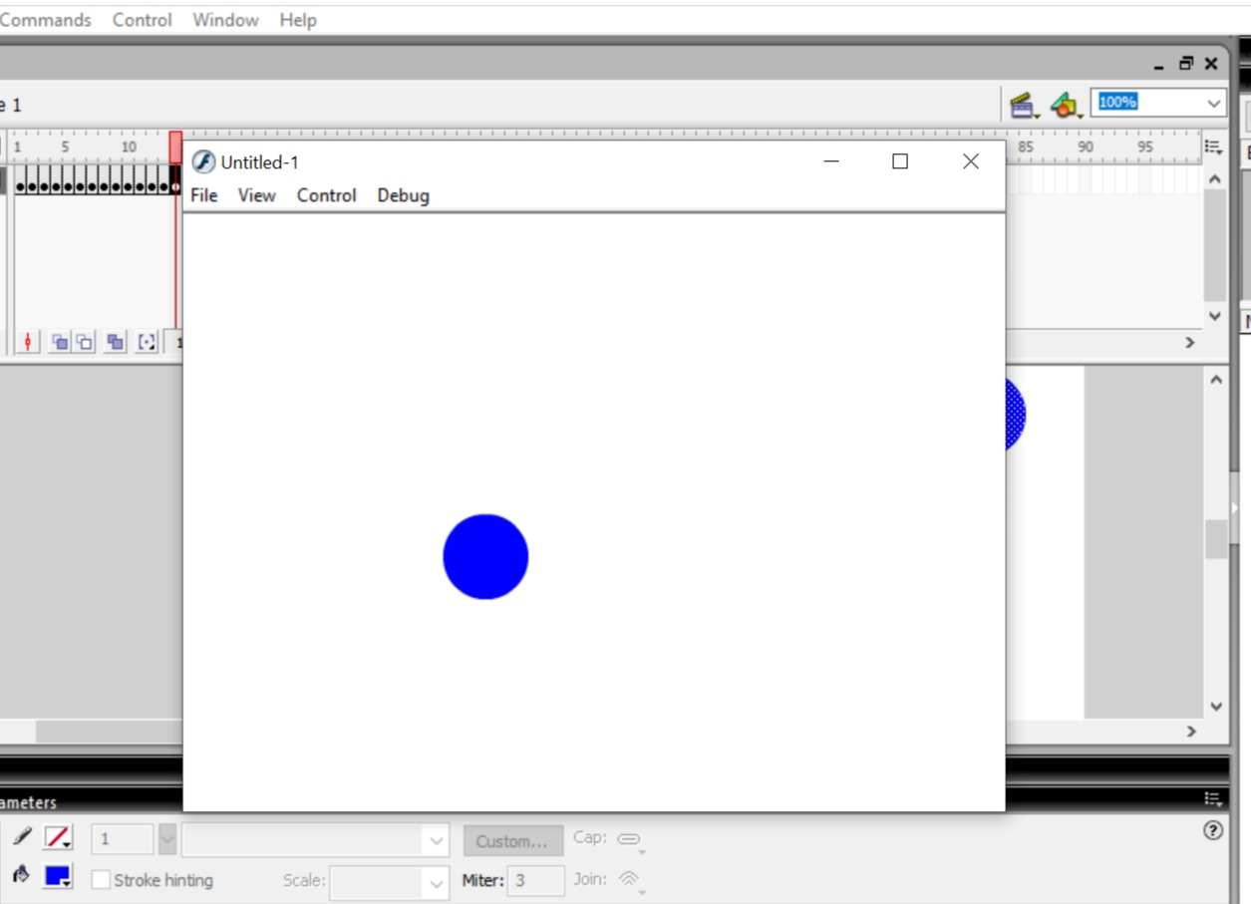

EXP 4:-..Design a shape tweening - Object to Object.

SOL:-

Step 1: Open macromedia flash.

Step 2: Now using the rectangle tool draw a rectangle on the first frame on the timeline.

Step 3: Now go to any other frame say 15 and click on F6 to insert a frame and draw a circle.

Step 4: Now click on any frame in between and right-click.

Step 5: Click on Shape tween.

Step 6: Shape tween is ready. Now Click on the play button on the timeline.

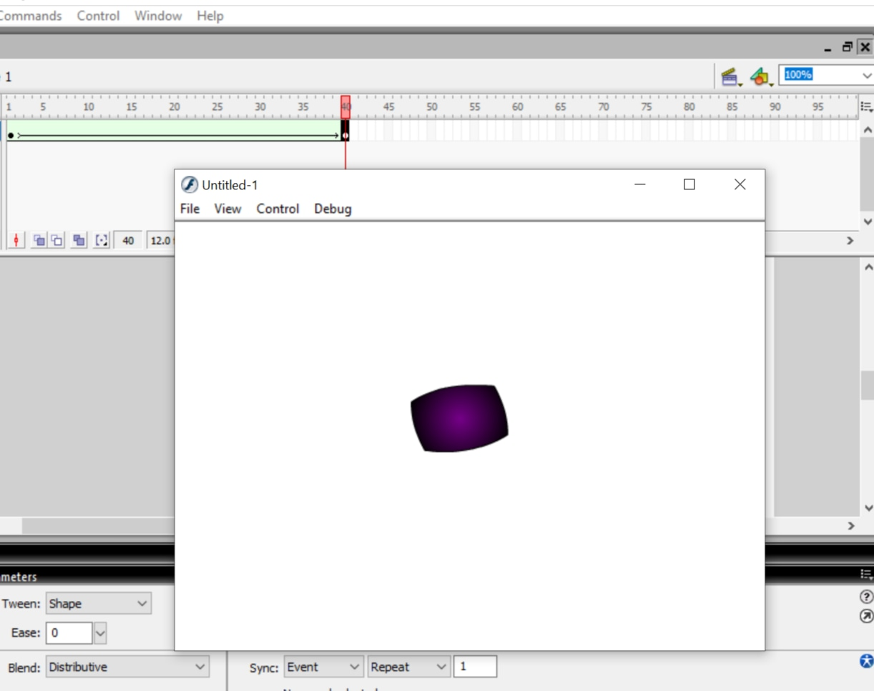

EXP 5:-..Design shape tweening- Object to Alphabet.

SOL:-

Step 1: Open macromedia flash.

Step 2: Now using the rectangle tool draw a rectangle on the first frame on the timeline.

Step 3: Now go to any other frame say 15 and click on F6 to insert a frame and draw a circle.

Step 4: Now click on any frame in between and right-click.

Step 5: Click on Shape tween.

Step 6: Shape tween is ready. Now Click on the play button on the timeline.

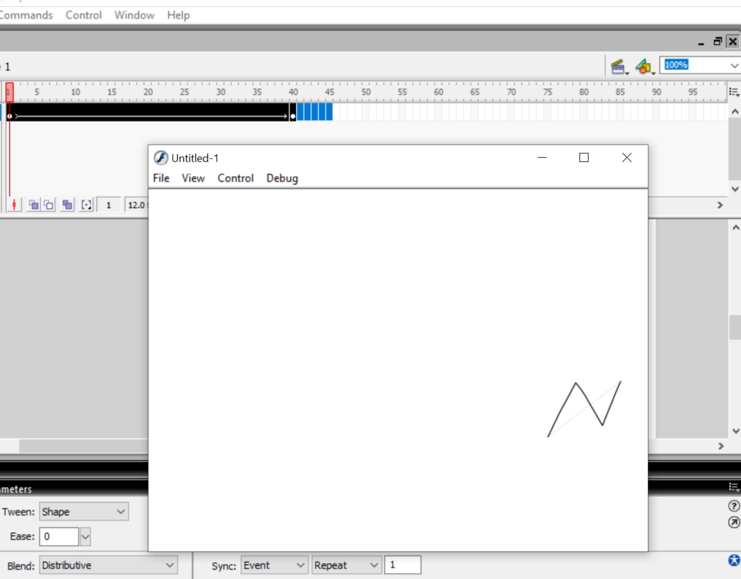

EXP 6:-.. Design shape tweening- Alphabet to Object.

SOL:-

Step 1: Open macromedia flash.

Step 2: Now using selection tool draw an alphabet on the first frame on the timeline.

Step 3: Now go to any other frame say 15 and click on F6 to insert a frame and draw a circle .

Step 4: Now click on any frame in between and right-click.

Step 5: Click on Shape tween.

Step 6: Shape tween is ready. Now Click on the play button on the timeline.

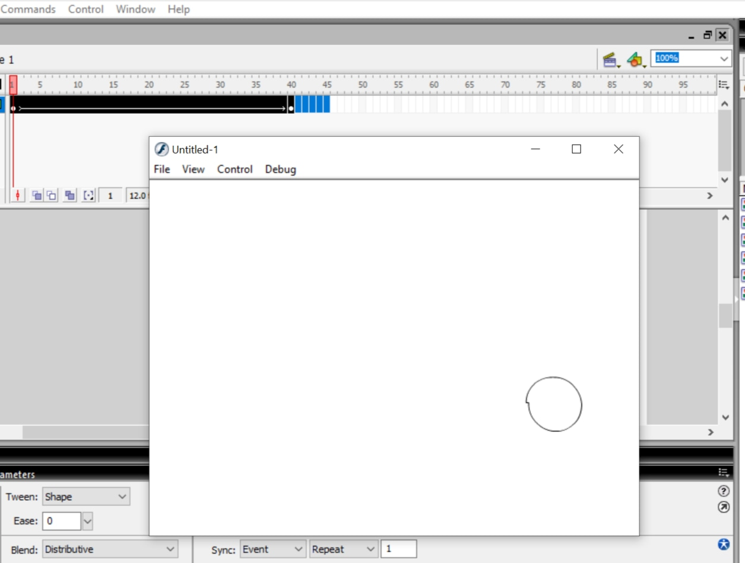

EXP 7:- Create spotlight using Macromedia Flash.

SOL:-

Step 1: Open macromedia flash.

Step 2: Create a file with the parameters (remember carefully what color you chose for the background).

Step 3: Select the Rectangle Tool , remove the border color and select a light-colored color .Draw a rectangle .

Step 4: Use the Selection Tool to shape it into a triangle with a round rounded bottom.

Step 5: Right-click Frame 2 and select Insert KeyFrame .

Step 6: Do the same step 5 for Frame 3, 4, 5, 6, and 7.

Step 7: Create a new layer on the existing Layer 1 .

Step 8: Click on Frame 1 of Layer 2 ( newly created ). Select the Text tool and type in the words Multimedia .

Step 9: Right-click Frame 2 of Layer 2 and select Insert KeyFrame .

Step 10: Do the same step 9 for Frame 3, 4, 5, 6, and 7 of Layer 2.

Step 11: Click on Frame 1 of Layer 2 to select it, select the Text tool , use the mouse to highlight the characters outside the triangle created in Step 4, and adjust the color to match the color of the background ( 9 after color correction).

Step 12: Click on Frame 2 of Layer 1 , right-click on the triangle and select Free Transform and adjust the slightly larger triangle.

Step 13: Do the same Step 11 for Layer 2 of Layer 2.

Step 14: Do the same for the rest of the two layers.

Step 15: Press Ctrl + Enter to check the result.

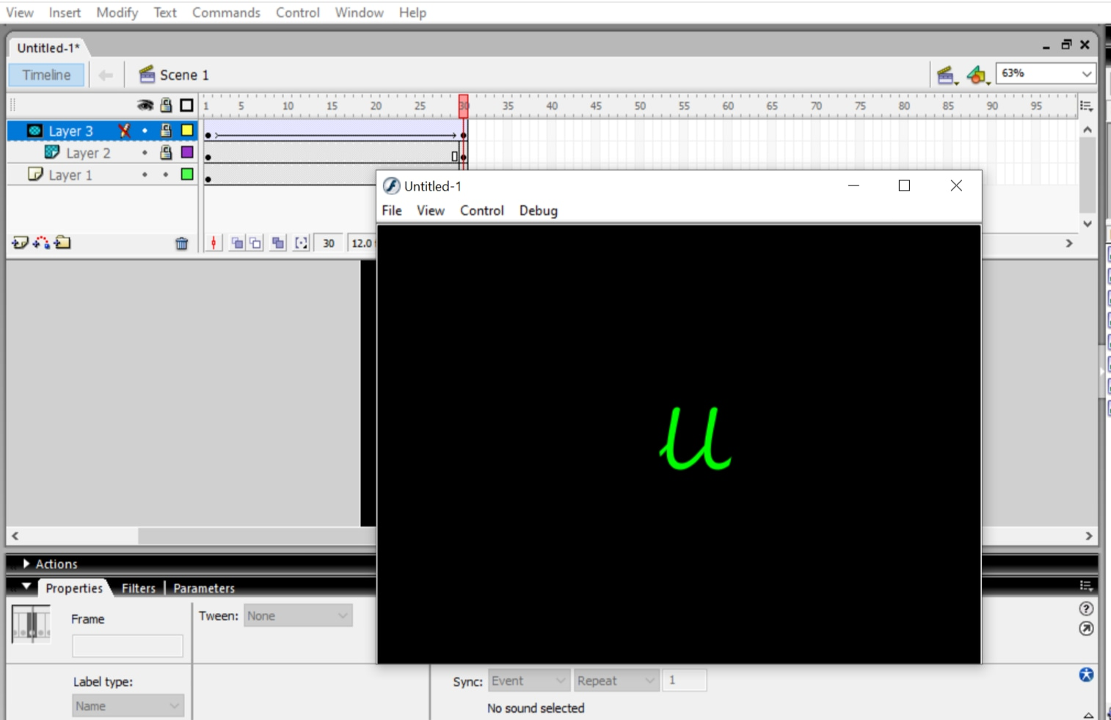

Exp 9-.. Create Animated Pool Table.

SOL:-

Step 1: Open Macromedia Flash 10.

Step 2: Choose frame 1 on the timeline which is located above the canvas.

Step 3: Draw whatever you want to in your first frame.

Step 4: Choose the next frame depending upon the length of your animation.

Step 5: Right click on the frame and click "Insert KEYFrame".

Step 6: Right click anywhere between the first and the last frame and select "Create Motion Tween".

Step 7: Edit the picture in any way.( We can change its size, position or other effects such as alpha, tint, etc. They appear when we right click on the object and click "Properties".)

Step 8: Press Ctrl+↵ Enter to view the animation.

Step 9: Ctrl +Enter to check the result.

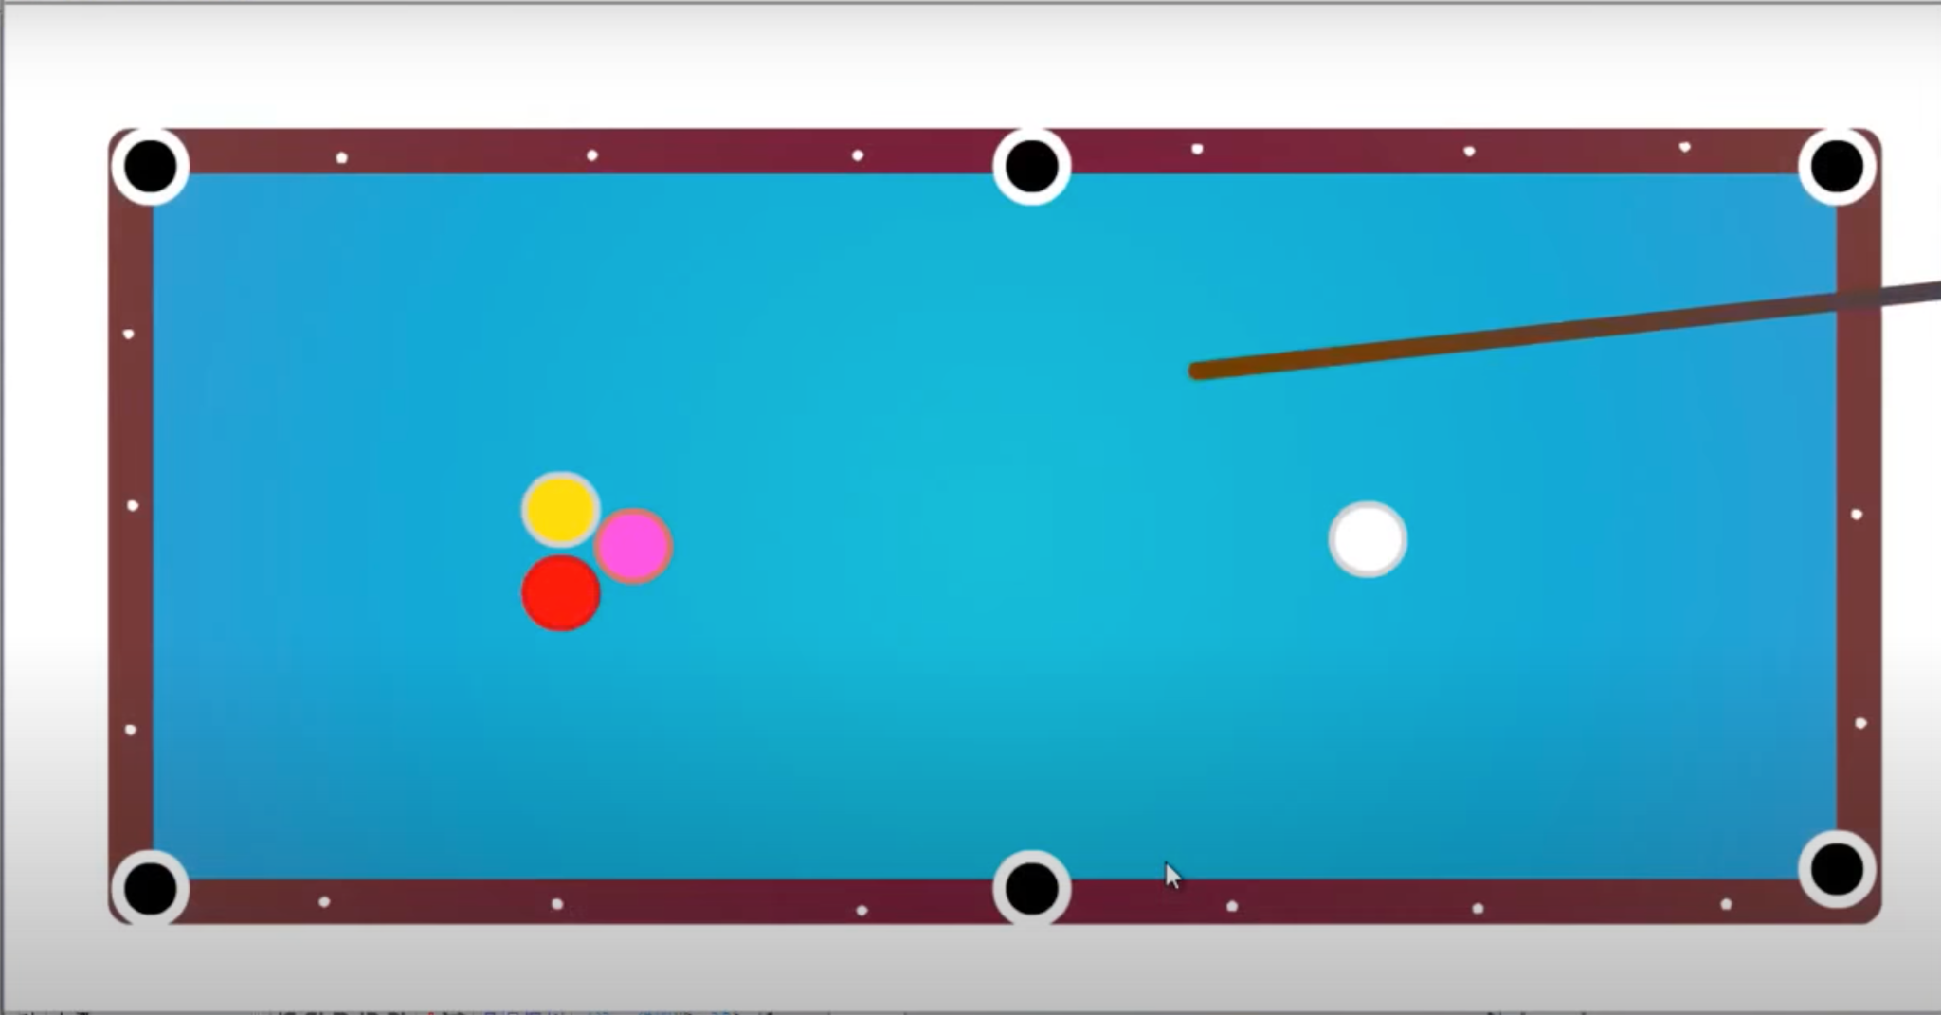

Exp 10:-.. Create Bow & Arrow hitting a ball.

SOL:-

Step 1: Open macromedia flash.

Step 2:Take a new file.

Step 3:click on import and then click to stage .

Step 4:Rename the layer - grass_background-open.

Step 5:Download the png. image -scale it to full screen .

Step 6:Give name to layer 1 as background and then layer 2 as Target .

Step 7:we need to create Target like oval and fill the colour , shift it to the scenery.

Step 8:et's create another layer 3 , give name -Bow.Then draw bow on the scenery

Step 9: Create another layer 4(Arrow).

Step 10: let's create arrow and shift it to the scenery .

Step 11: Now it's time to give the animation effect, for this I have to animate the bow - Create and set keyframe.

Step 12: For target - insert blank keyframe .

Step 13: Set keyframe for both -Target /Background .

Step 14:After inserting - select arrow and bend the bow up-to 5 frames and then create another keyframe up-to 10 frames after doing this, bring it back.

Step 15: After that select arrow and move our arrow up-to 5 frames and another keyframe up-to 10 frames and next one it will shift to the target.

Step 16: Ctrl+enter to play.

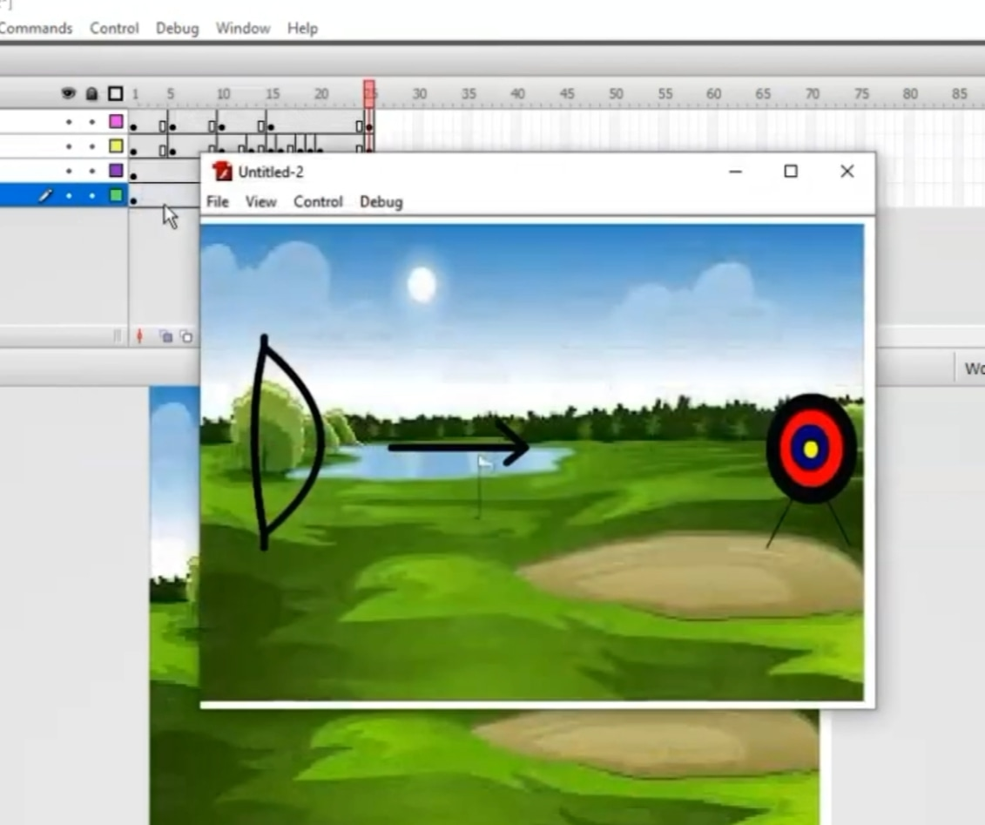

EXP 11:-..Write any Text with the illusion of pen writing letters.

SOL:-

Step 1: Open macromedia flash.

Step 2: We have to click text tool and then select the space and create H - now press ctrl + enter - select the larger version .

Step 3: Select the selection tool, make it as a center.

Step 4: click on the modify - break apart .

Step 5: zoom out/ zoom in.

Step 6: Select a eraser - eraser the text little bit - insert keyframe - again erase a little bit more - little bit - F6 / little bit -F6(shortcut).

Step 7: Click on the last frame - press shift and then click on the first frame .

Step 8: click on the all selected frames - right click - reverse frames, click -enter.

Step 9: Insert a new layer - click on the last frame .

Step 10: Click file - import - import to stage (pencil image) .

Step 11: Selection tool - insert keyframe - again and again for erasing .

Step 12: In every frame create motion .

Step 13: Press Ctrl+ enter.

